Machine Learning Experiment 2

DAMANDEEP SINGH | 02213202717 | CSE-1

# AIM:

Study and implement the Decision tree using Python Sklearn on Breast Cancer dataset.

# ALGORITHM:

1. Select the best attribute using Attribute Selection Measures (ASM) to split the records.
2. Make that attribute a decision node and breaks the dataset into smaller subsets.
3. Starts tree building by repeating this process recursively for each child until one of the conditions will match:
   1. All the tuples belong to the same attribute value.
   2. There are no more remaining attributes.
   3. There are no more instances.

# PROGRAM CODE SNIPPET:

## LOADING DATA SET:

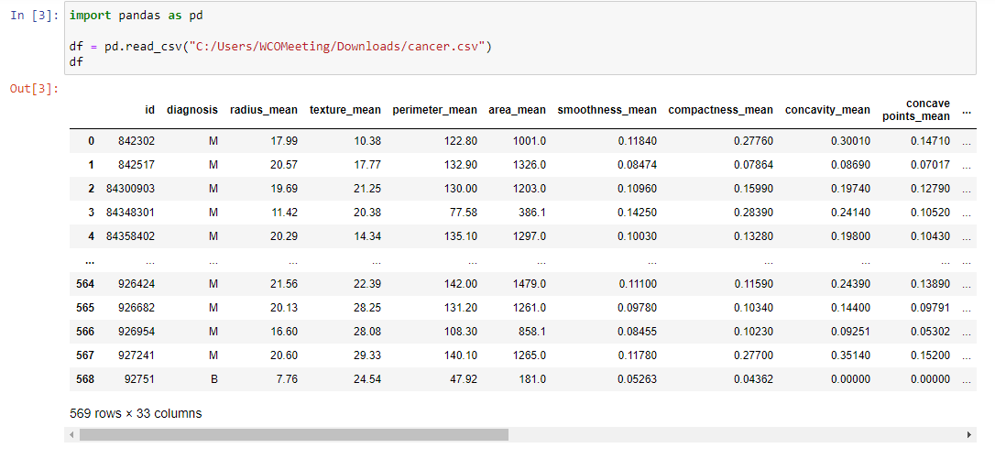

## PREPROCESSING:

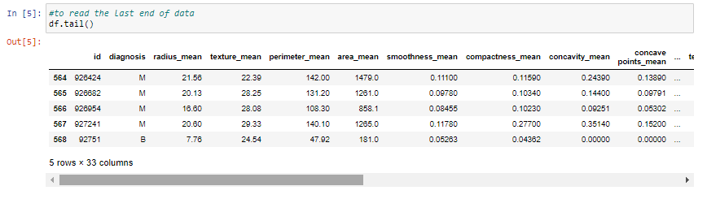

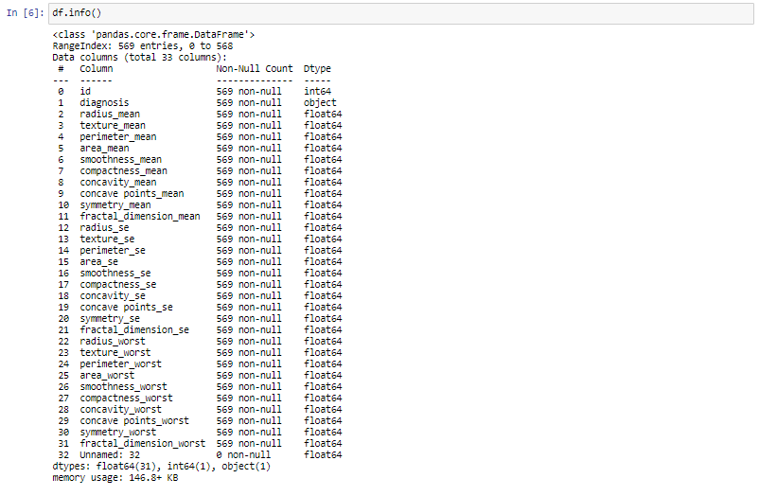

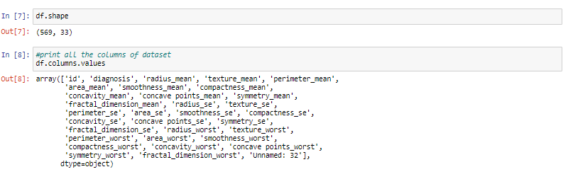

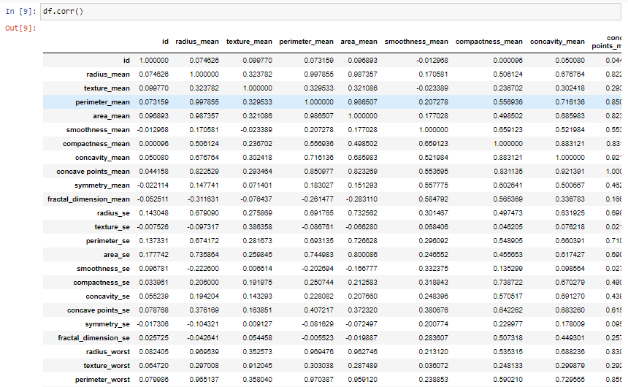

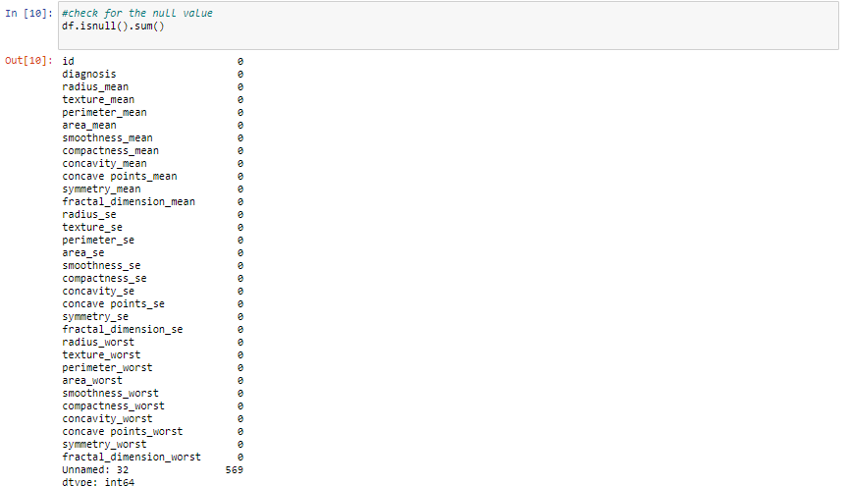

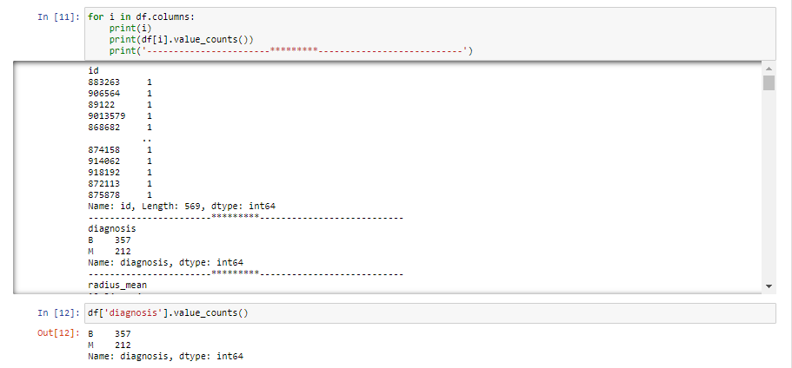

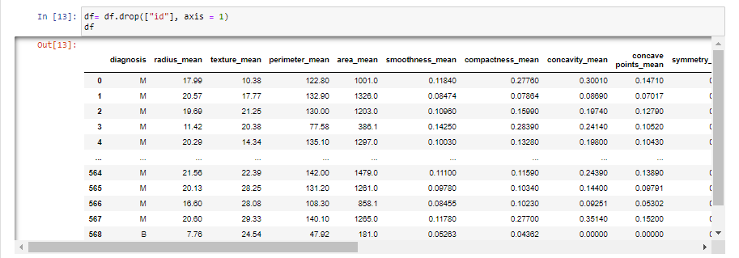

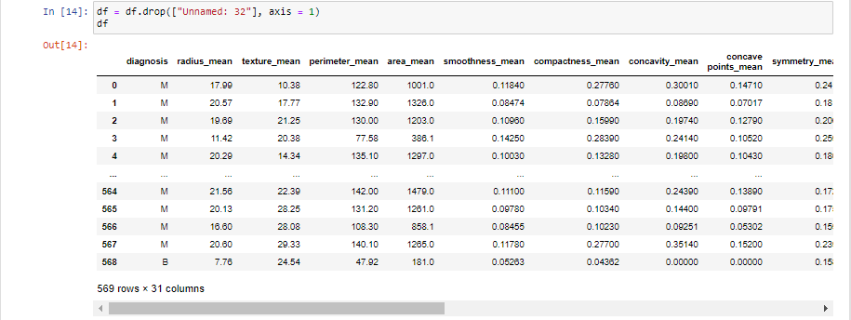

## VISUALIZATION:

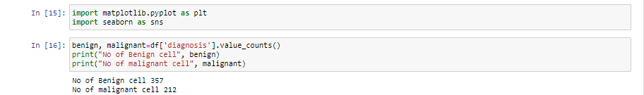

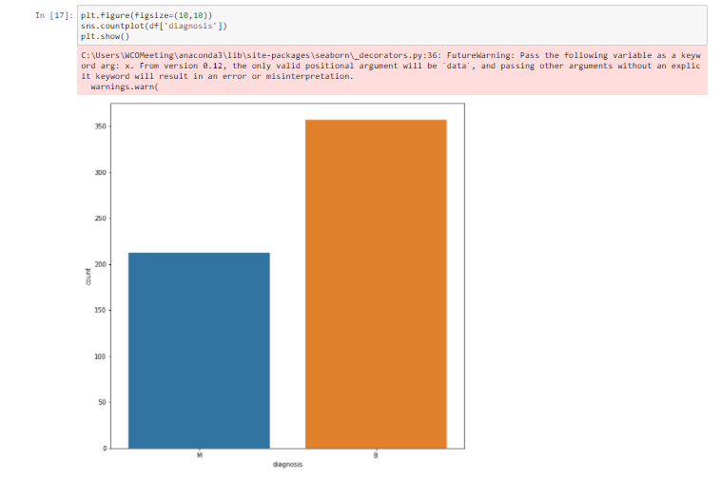

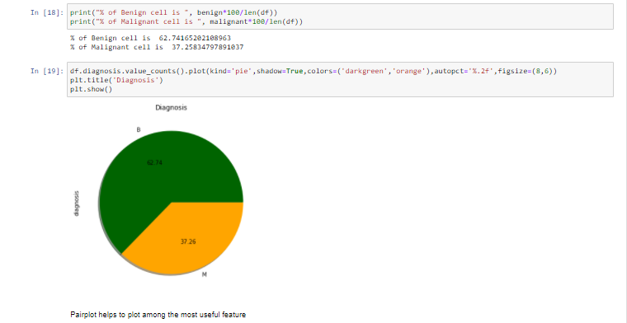

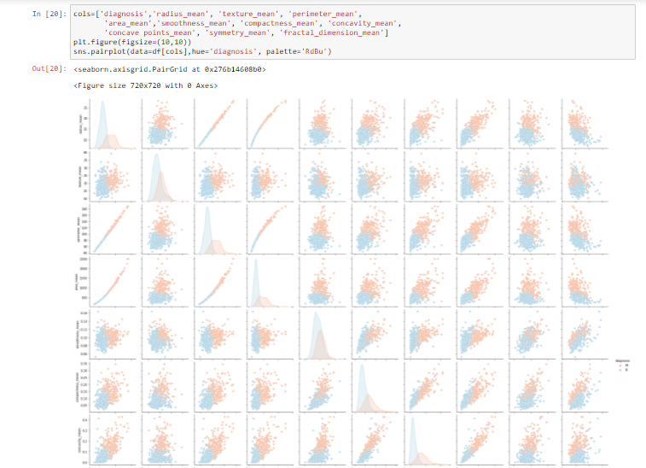

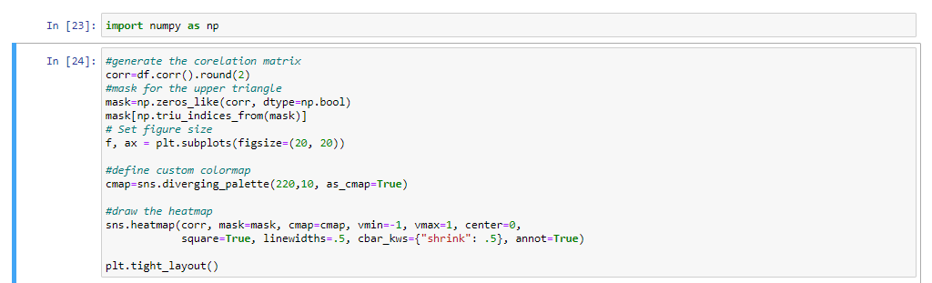

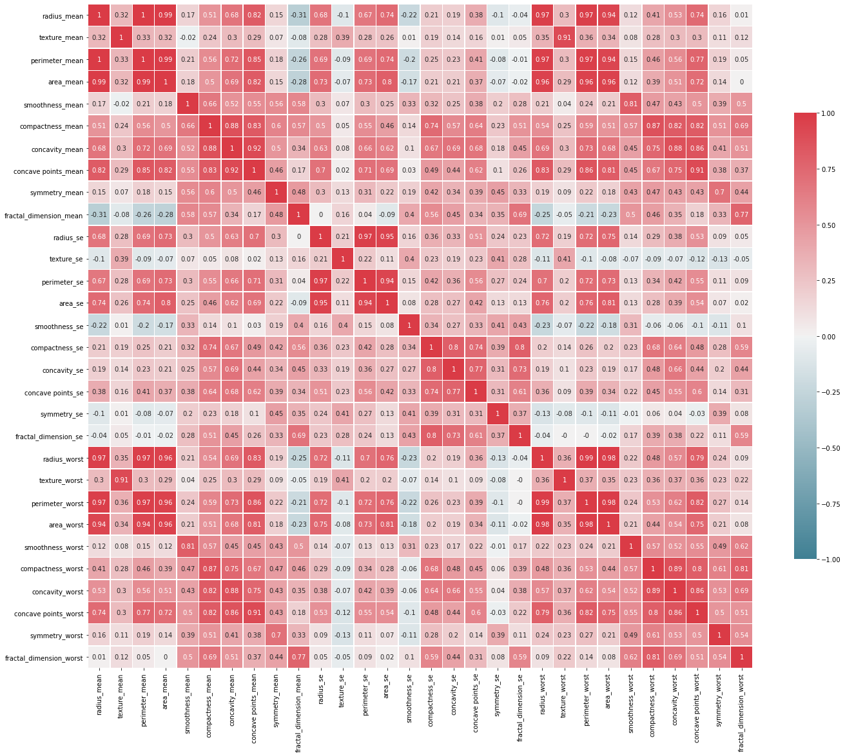

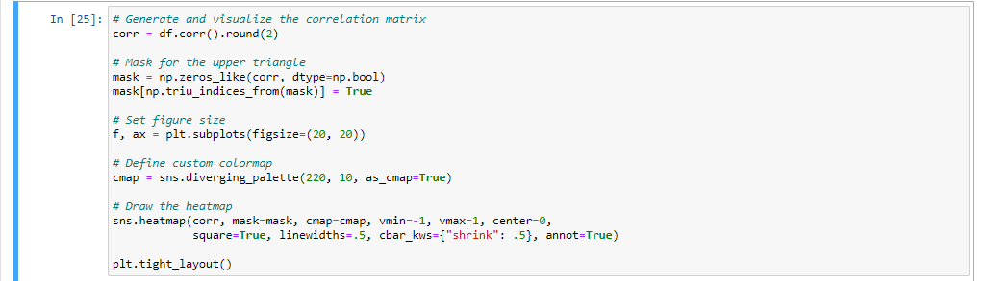

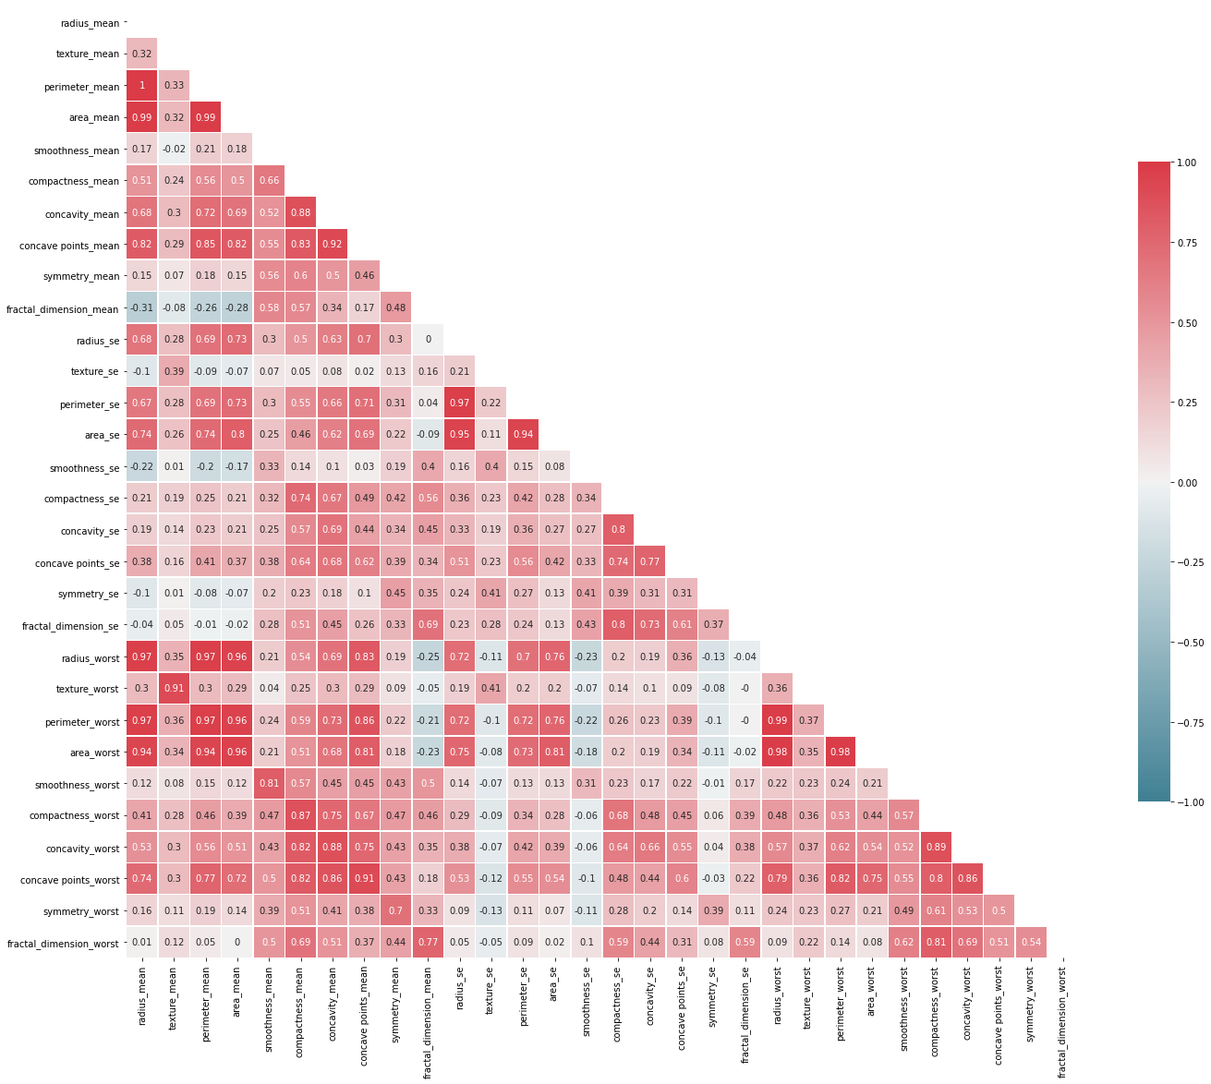

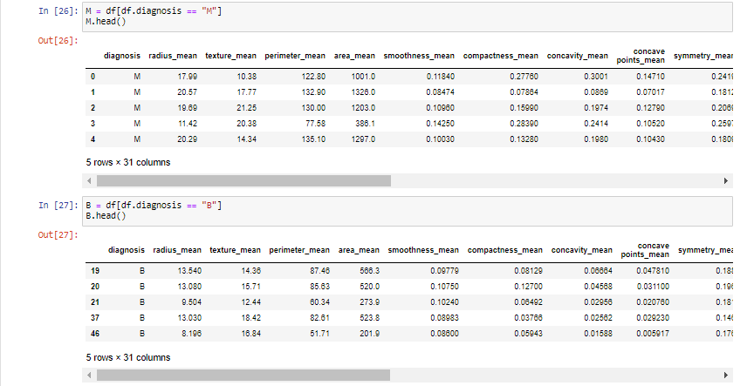

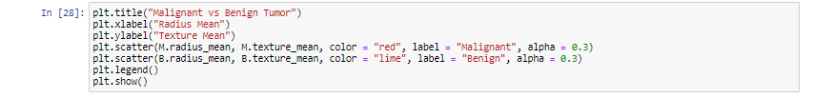

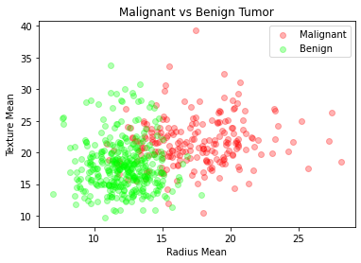

## ML ALGORITHM IMPLEMENTATION:

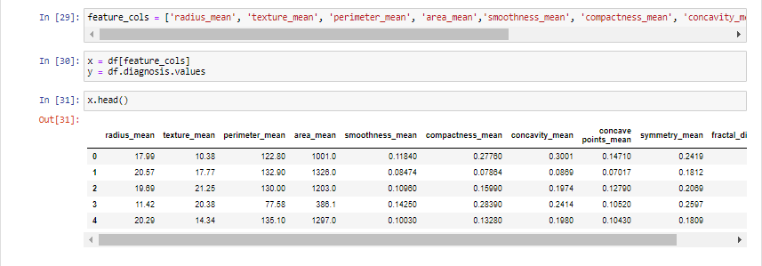

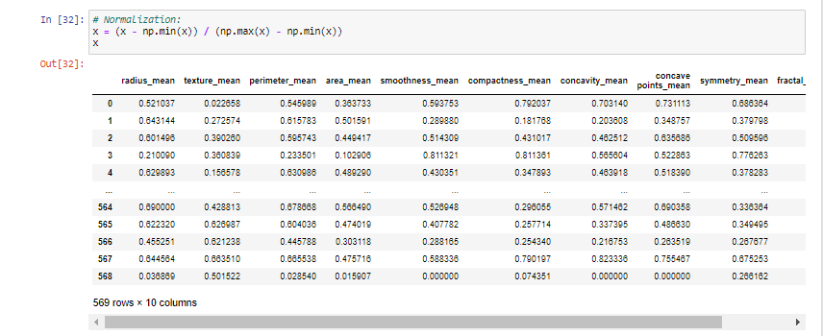

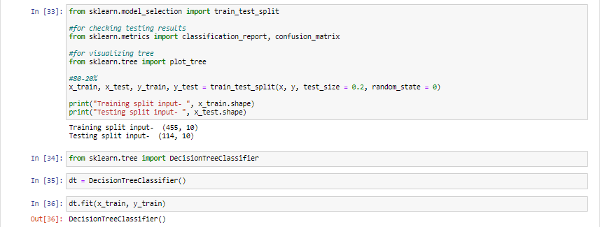

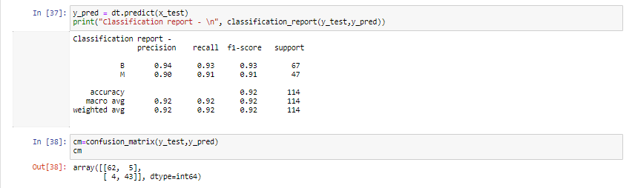

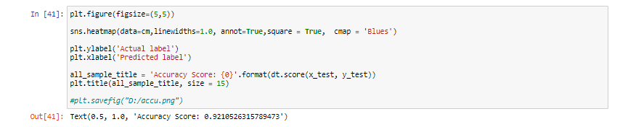

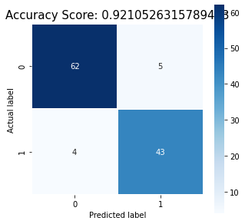

## FINAL GRAPHS:

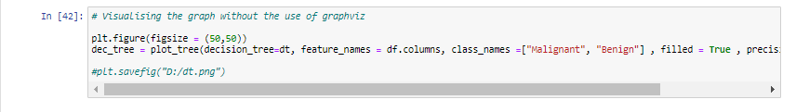

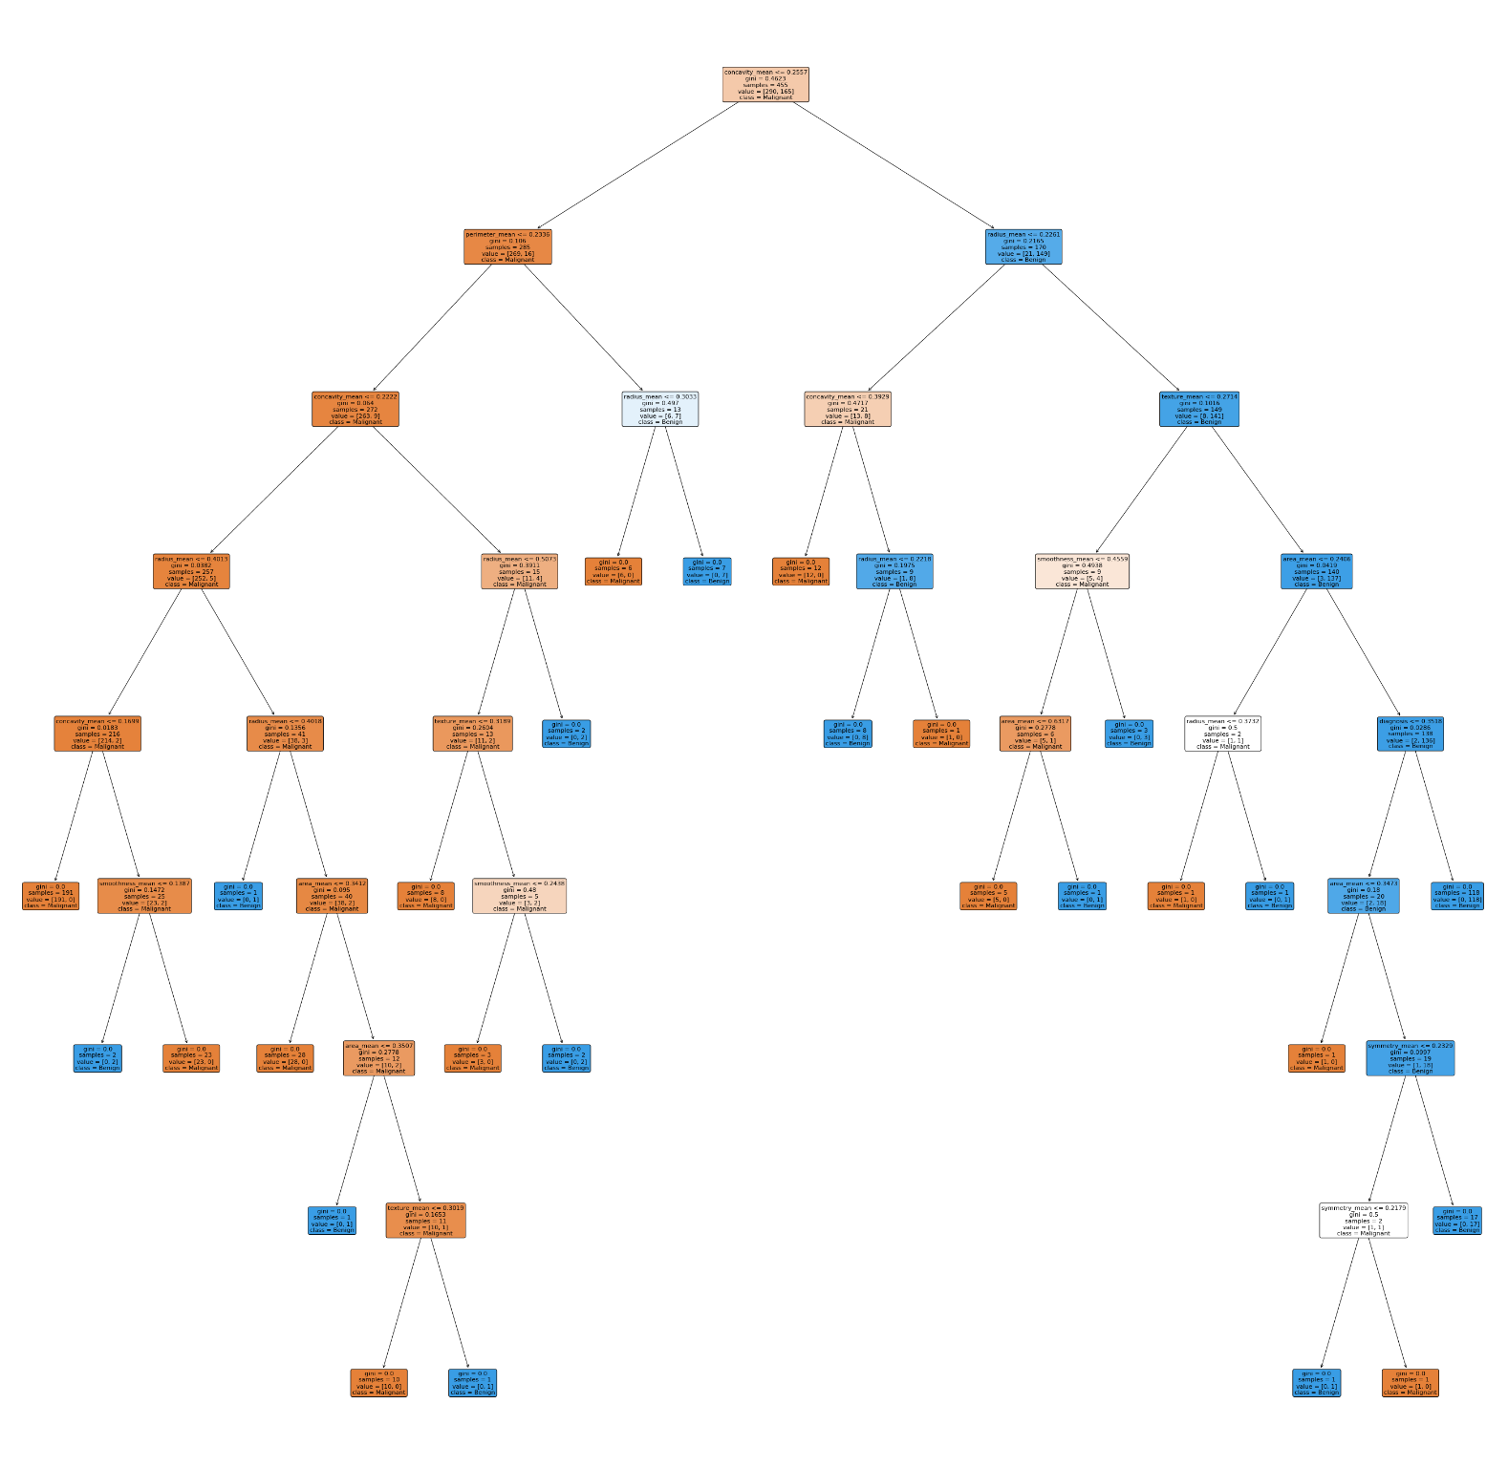

# GITHUB LINK:

<https://github.com/Damansandhu23/MLpracfile.git>